|  |  |
| --- | --- |
|  | **Sri Sivasubramaniya Nadar College of Engineering, Kalavakkam – 603 110**  **(An Autonomous Institution, Affiliated to Anna University, Chennai)**  Computer Science and Engineering  **CAT 1 & CAT2 – Assignments - Regulations – R2021** |

|  |  |  |  |  |  |  |  |
| --- | --- | --- | --- | --- | --- | --- | --- |
| Course Code | **UCS1601** | Course Name | Internet Programming | | | | |
| Course Type | **Theory** | Course Category | Professional Core (PC) | **L** | **T** | **P** | **C** |
| **3** | **0** | **0** | **3** |
| Regulation | **R-2021** | | Academic Year | **2023-24 (Even)** | | | |
| Degree and Branch | **B.E. Computer Science & Engineering** | | Batch | **2021-25** | | | |
| Semester | | **VI** | Faculty Name | **Mr. S. Raghavendra Kumar**  **Dr. B. Prabavathy** | | | |
| Department Offering the Course | | | **Computer Science and Engineering** | | | | |

**Deadline: 09.05.2024**

**Design of Recipe Finder Full Stack Web Application**

**Problem Description**

Design a full stack Recipe Finder web application which allows users to search for recipes based on the name of the recipe. The app can fetch data from various recipe APIs, display recipes, and provide additional details such as cooking instructions, nutritional information, and user reviews. Prepare a report containing the design, code, output snapshots, best practices used and learning outcomes.

[CO1, CO2, CO4, CO5, K5, 1.4.1, 2.1.2, 2.2.3, 3.2.1, 10.1.2, 13.3.1]

Here are some key features to consider:

* **Recipe Search:**Incorporate a search feature that empowers users to discover recipes by entering keyword.
* **Filtering and Sorting:**Provide options to filter and sort recipes based on criteria such as cooking time, difficulty level, and cuisine
* **Recipe Details:** Display detailed information about each recipe, including ingredients and step-by-step instructions along with the image.
* **Saved Recipes:**Allow users to save their favorite recipes for future reference. Provide a personal recipe collection where users can manage and organize their saved recipes

Design the following:

* Most appealing layout template
* Schema of the necessary MongoDB collections
* Necessary endpoints, controllers, collections, and components as a sequence diagram

Do the following operations:

* Sending appropriate GET http requests from front end, to the endpoint in the node server.

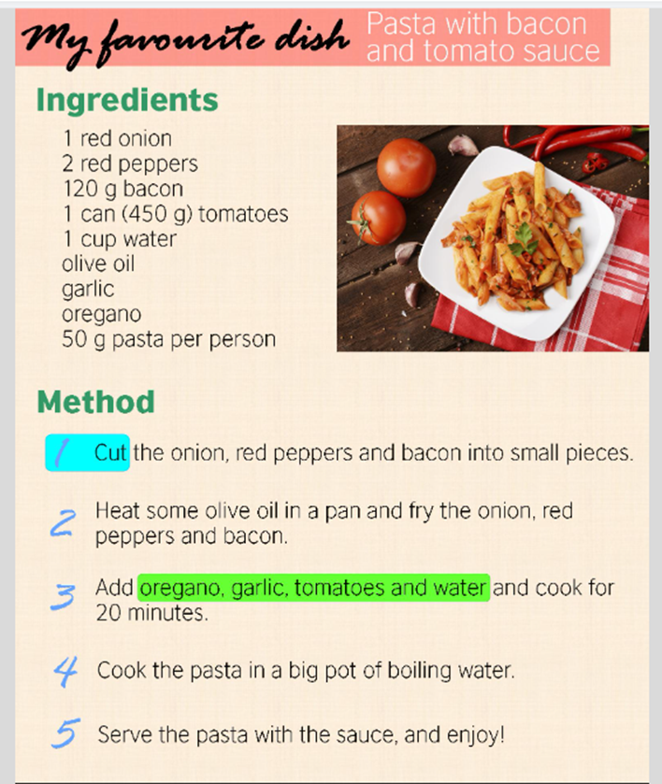

Prepare a report containing the following: **[10.1.1, 10.1.2]**

1. Draw the design, write the collections used
2. Code with snapshots